Name: .

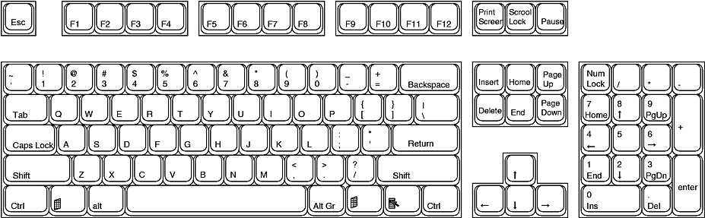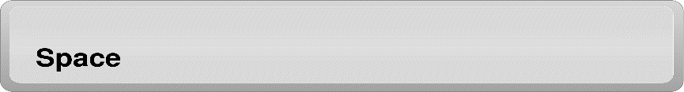Teacher: .



**Enter**

