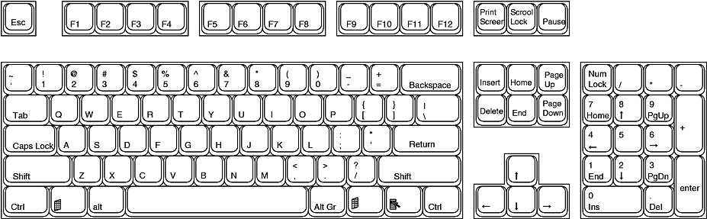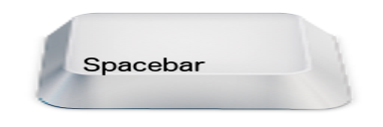**Name**: ___________________________________________ **Teacher**: _______________________