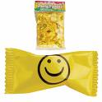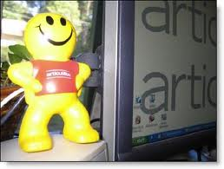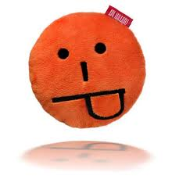

**Directions**:

**Crop** as much of **each** **smiley** **picture** on **page 1** as you can **without** cropping smiley himself!

**Directions**:

**Crop** as much of **each** **smiley** **picture** on **page 2** as you can **without** cropping smiley himself!

**Directions**:

**Crop** as much of **each** **smiley** **picture** on **page 3** so smiley has a more **square** face!